**REGISTRATION_3.jsp**

<%@ page language="java" contentType="text/html; charset=ISO-8859-1"

pageEncoding="ISO-8859-1"%>

<!DOCTYPE html PUBLIC "-//W3C//DTD HTML 4.01 Transitional//EN" "http://www.w3.org/TR/html4/loose.dtd">

<html>

<head>

<meta http-equiv="Content-Type" content="text/html; charset=ISO-8859-1">

<title>Herb Online Shopping Login Form</title>

</head>

<body>

<form action="registration_2" method="post">

<table style="with: 50%">

<tr>

<td>UserName</td>

<td><input type="text" name="username" /></td>

</tr>

<tr>

<td>Password</td>

<td><input type="password" name="password" /></td>

</tr>

</table>

<input type="Submit" value="Login" /></form>

</body>

</html>

**REGISTRATION_4.jsp**

<%@ page language="java" contentType="text/html; charset=ISO-8859-1"

pageEncoding="ISO-8859-1"%>

<!DOCTYPE html PUBLIC "-//W3C//DTD HTML 4.01 Transitional//EN" "http://www.w3.org/TR/html4/loose.dtd">

<html>

<head>

<meta http-equiv="Content-Type" content="text/html; charset=ISO-8859-1">

<title>Guru Logged In</title>

</head>

<body>

<table style="with: 50%">

<tr><td>

<% String username = request.getParameter("username"); %>

<h1><a>Welcome <% out.println(username); %> to Herb Online Shopping!!!!</h1></td></tr>

<tr></tr><tr><td></td><td></td><td><a href="registration_3.jsp"><b>Logout</b></a></td></tr>

</table>

</body>

</html>

**REGISTRATION_2.java**

import java.io.IOException;

import java.io.PrintWriter;

import javax.servlet.RequestDispatcher;

import javax.servlet.ServletException;

import javax.servlet.annotation.WebServlet;

import javax.servlet.http.HttpServlet;

import javax.servlet.http.HttpServletRequest;

import javax.servlet.http.HttpServletResponse;

@WebServlet(urlPatterns = {"/registration_2"})

public class registration_2 extends HttpServlet {

public registration_2() {

super();

// TODO Auto-generated constructor stub

}

protected void doPost(HttpServletRequest request, HttpServletResponse response) throws ServletException, IOException {

// TODO Auto-generated method stub

String username = request.getParameter("username");

String password = request.getParameter("password");

if(username.isEmpty() || password.isEmpty() )

{

RequestDispatcher req = request.getRequestDispatcher("registration_3.jsp");

req.include(request, response);

}

else

{

RequestDispatcher req = request.getRequestDispatcher("registration_4.jsp");

req.forward(request, response);

}

}

}

**EXAMPLE OUTPUT**

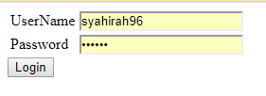

1. Enter username and password then click “Login” button.

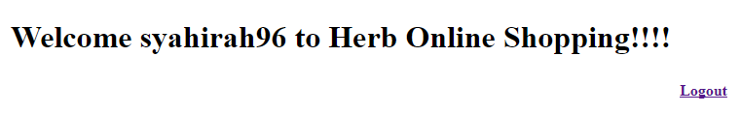

1. System will display Welcome syahirah96 to Herb Online Shopping!!
2. Click “Logout” button to quit from system

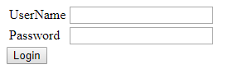

1. After logout system will display this window.